**RESEARCH STUDY:**

**YOUR SOCIAL EXPERIENCES AT UNIVERSITY**

You are invited to take part in our 25-minute online survey about your social experiences at university. Participants may enter a prize draw with a 1 in 10 chance of winning a $30 electronic gift certificate.

**For more information, visit** [**https://bit.ly/uniexperiences**](https://bit.ly/uniexperiences)

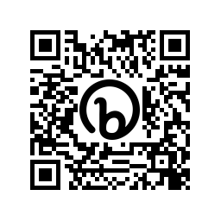



The Chief Investigator is [Olivia.Evans@anu.edu.au](mailto:Olivia.Evans@anu.edu.au) This project has been approved by the Australian National University Human Research Ethics Committee, Approval No 2021/817

|  |  |  |  |  |  |  |  |  |  |  |  |  |
| --- | --- | --- | --- | --- | --- | --- | --- | --- | --- | --- | --- | --- |
| [**https://bit.ly/uniexperiences**](https://bit.ly/uniexperiences) | [**https://bit.ly/uniexperiences**](https://bit.ly/uniexperiences) | [**https://bit.ly/uniexperiences**](https://bit.ly/uniexperiences) | [**https://bit.ly/uniexperiences**](https://bit.ly/uniexperiences) | [**https://bit.ly/uniexperiences**](https://bit.ly/uniexperiences) | [**https://bit.ly/uniexperiences**](https://bit.ly/uniexperiences) | [**https://bit.ly/uniexperiences**](https://bit.ly/uniexperiences) | [**https://bit.ly/uniexperiences**](https://bit.ly/uniexperiences) | [**https://bit.ly/uniexperiences**](https://bit.ly/uniexperiences) | [**https://bit.ly/uniexperiences**](https://bit.ly/uniexperiences) | [**https://bit.ly/uniexperiences**](https://bit.ly/uniexperiences) | [**https://bit.ly/uniexperiences**](https://bit.ly/uniexperiences) |  |