Hello all UniSFA Freshers!

Welcome to our amazing community of   
Science Fiction and Fantasy fans.

Please request to join the Facebook group  
so you can keep in touch with everything   
happening in the club:

**UniSFA Freshers 2019**Our club has hundreds of books, as well as many graphic novels, movies and even a few video games for everyone to enjoy. Talk to a committee member or CCC member to set up your own Koha account so you can borrow all you want, or if you just want to chat. Every week we have screenings which you can come along to for free, and feel free to recommend a screening idea to anyone on committee.

If you would like more of an introduction to the clubroom, please feel free to contact me via email or Facebook and I will gladly show you around anytime.

Here are a couple of maps to the clubroom if you get lost.

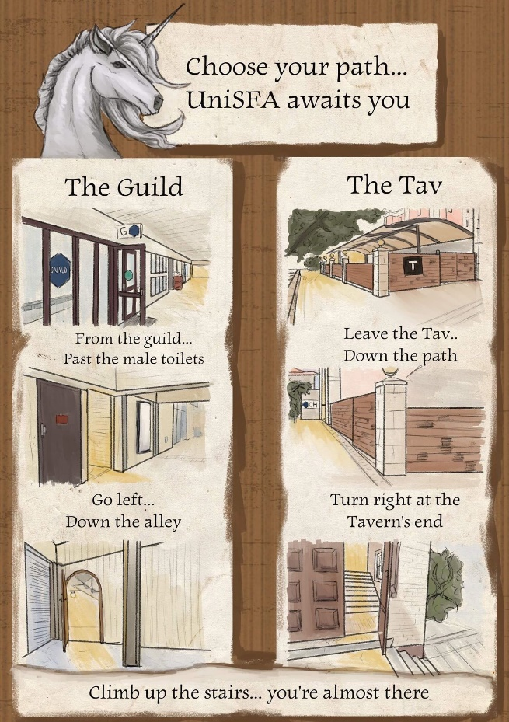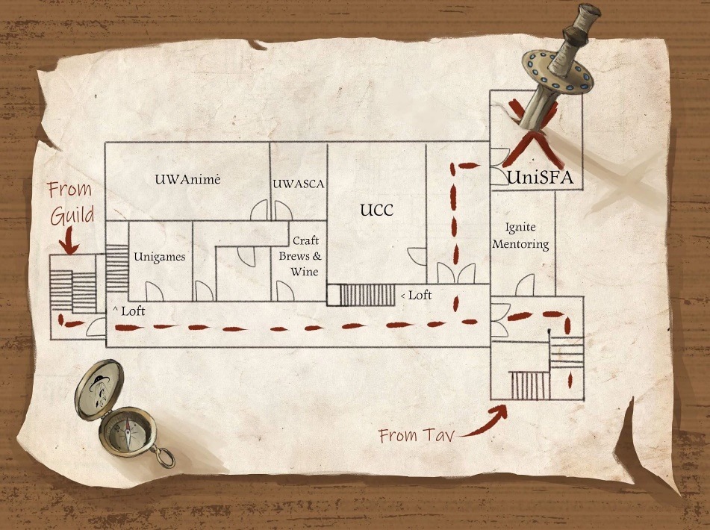



UniSFA is part of the Cameron Hall Quiz for 2019!  
Come down to the UWA Tavern on the 10th of May for a night of trivia, fun and games.  
Contact me if you would like to be on a fresher table.  
When? 10th may at 6:30pm – 10:30pm  
Where? UWA Tavern

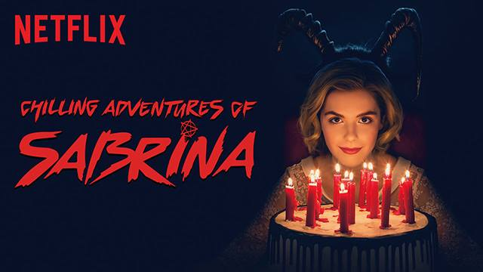

Wild Witch Fridays are happening!  
Come along and watch an episode of The Chilling Adventures of Sabrina followed by an episode of Wizards of Waverly Place.  
When? Every Friday, from 5pm  
Where? UniSFA Clubroom  
(Will not be screened on the 26th Feb due to avengers)



Hosted by Will Corbett we have the final season of Game of Thrones. On every Monday night, you can’t miss it if you’re a fan.  
When? Every Monday at 5:30pm  
Where? UniSFA Clubroom



UniSFA is watching Avengers: Endgame this Friday. If you would like to come along and buy a ticket let Katherine know before Thursday as we book as a group.  
When? Friday the 23rd of April (3pm-7pm)  
Where? Palace Cinemas (Raine Square, Perth)  
Cost? $12 paid at the cinemas

There are plenty of events (shown above and more on the Facebook group) that are happening soon for you to look forward to. Please check them out and come along if you can.

This year is going to be a blast and I hope you all enjoy it!

Your Fresher Rep for 2019, Amy Papasergio